Context

Trial registration 2

Working with Trial object type. 2

Setting trials for Trial object type. 3

Adding reference value and standards. 4

Entering trial’s results 6

How to activate English interface. 7

# Trial registration

To enter information about a trial, user should press the Trial registration link on the starting screen.

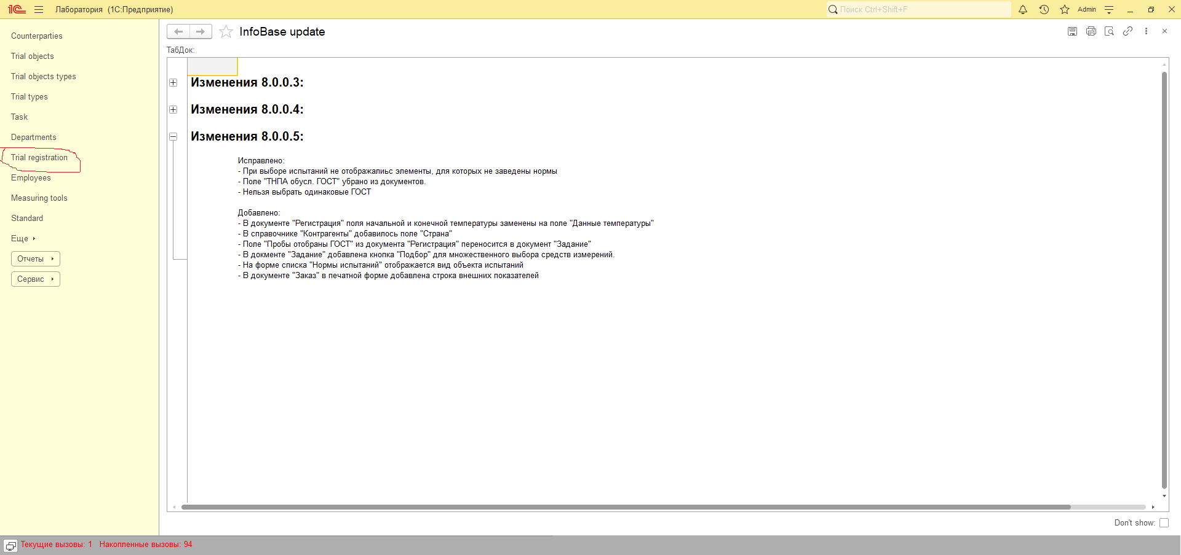

Then or an existing document should be chosen or a new one by pressing the Create button.

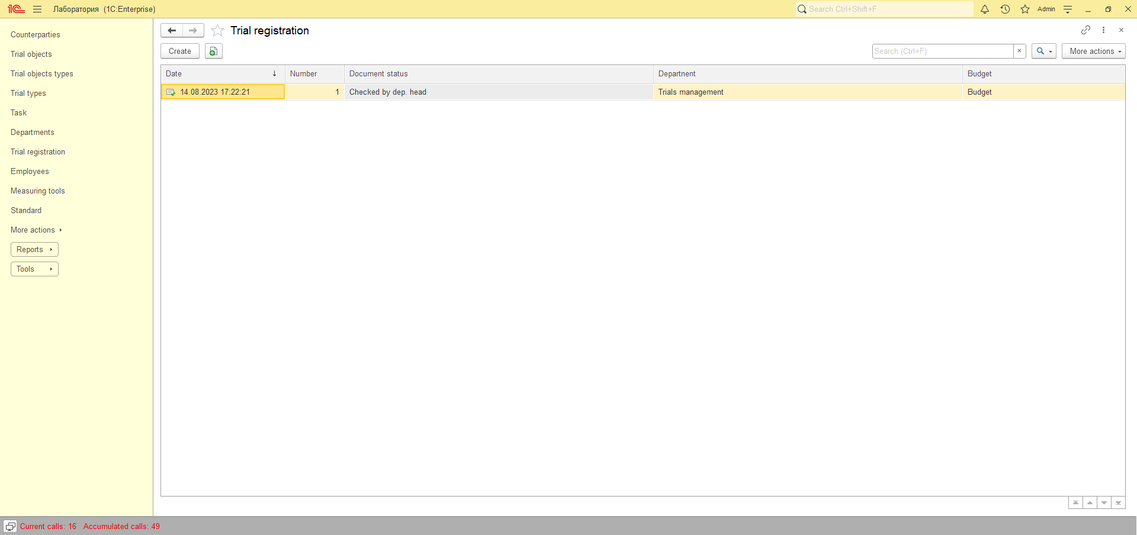

On the following screen there is the example of how the initial datum has to be entered.

## Working with Trial object type.

There are some peculiarities of filling the right table which is encircled by red.

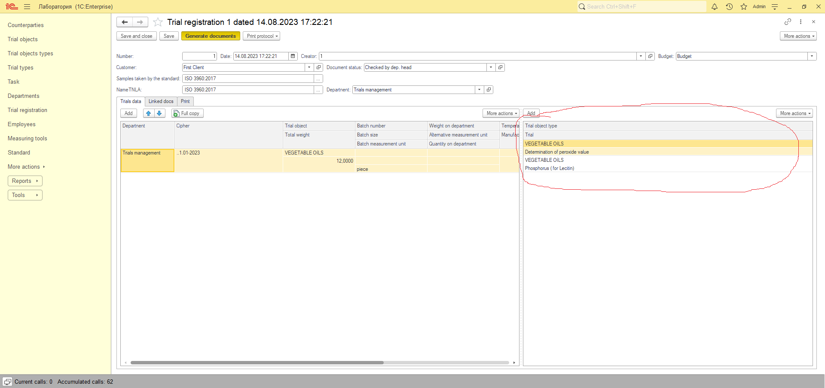

Trial object type can be selected by pressing “3 dots” button (encircled by red)

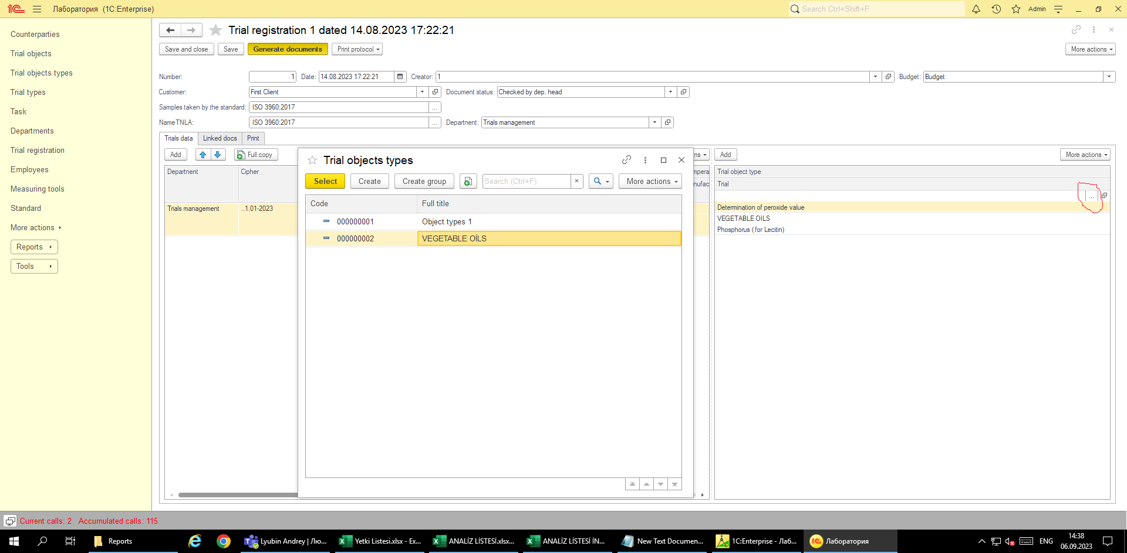  
Item should be or selected or a new one created: (pressing More actions gives access to edit the existing item.)

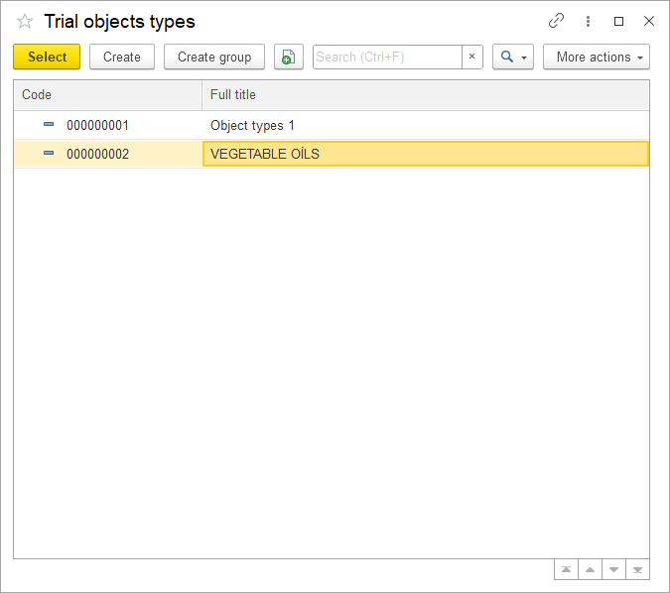

## Setting trials for Trial object type.

To add trials results, user should press Open trials button:

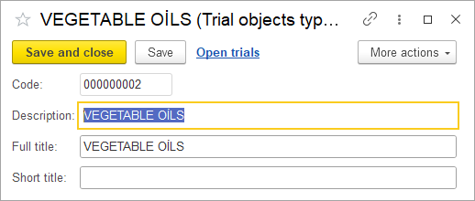

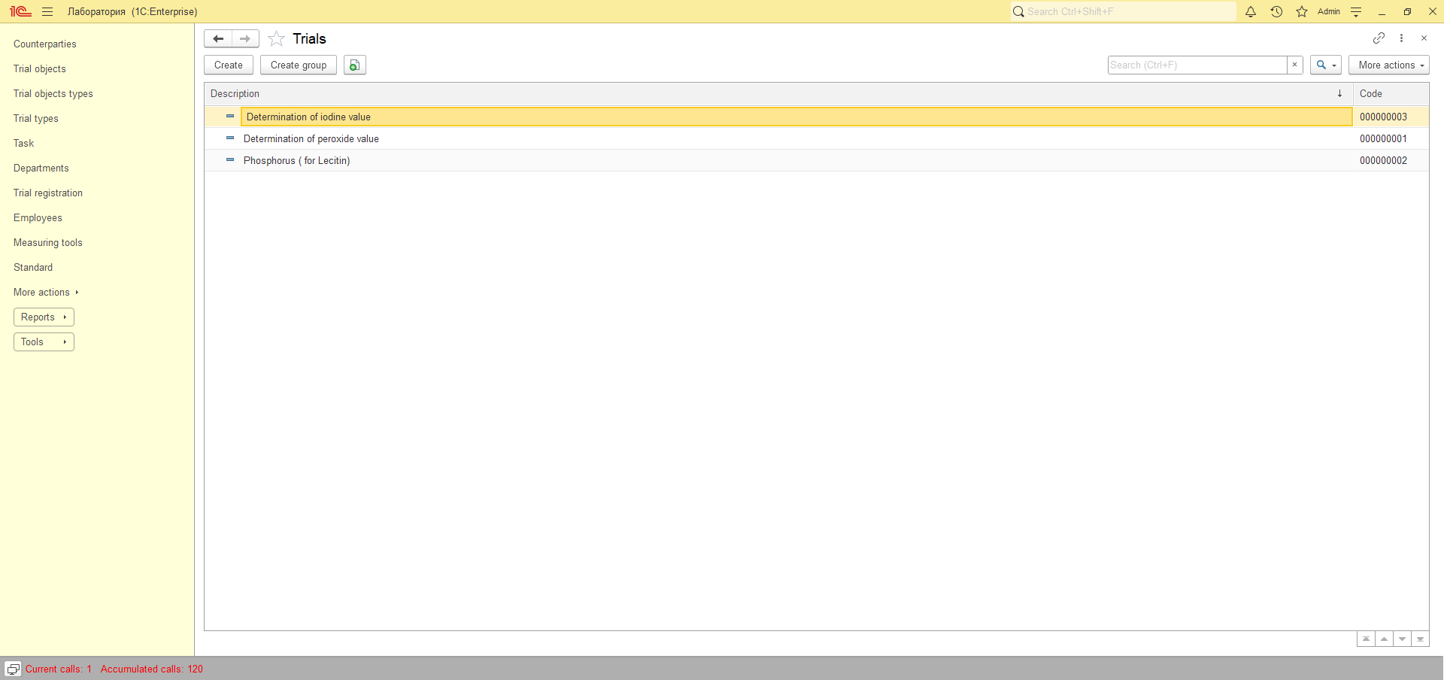

## Adding reference value and standards.

During creation or editing the item user can add reference value for the trial by pressing Add reference value button.

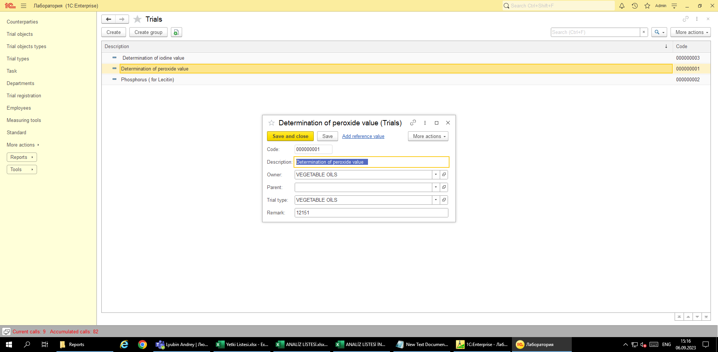

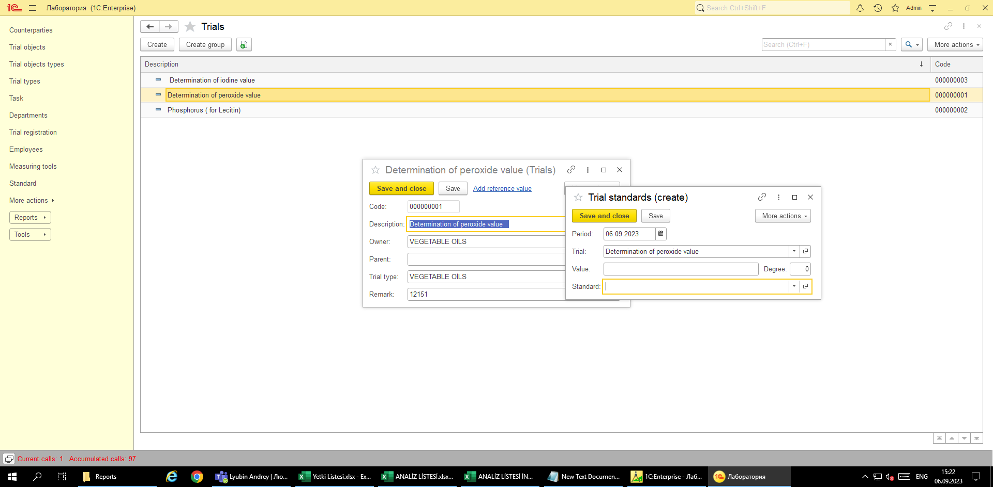

The standards for the trial can be added on this screen too.

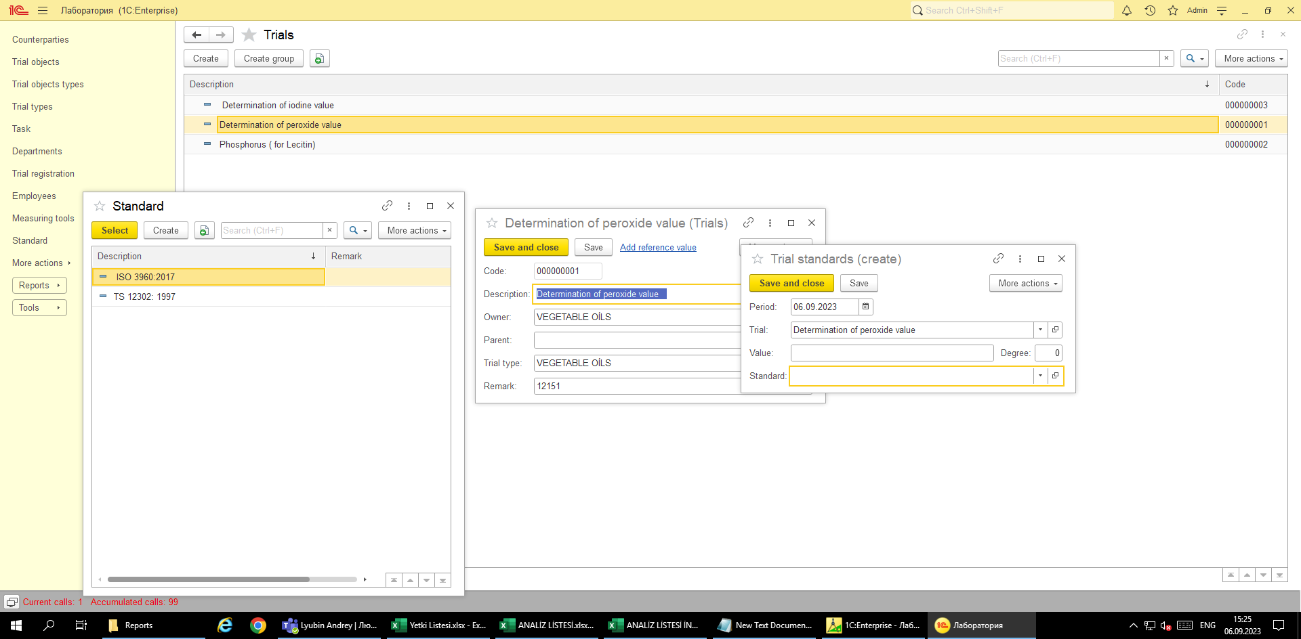

After all necessary data were entered the user can press **More actions** button to choose **Generate documents**.

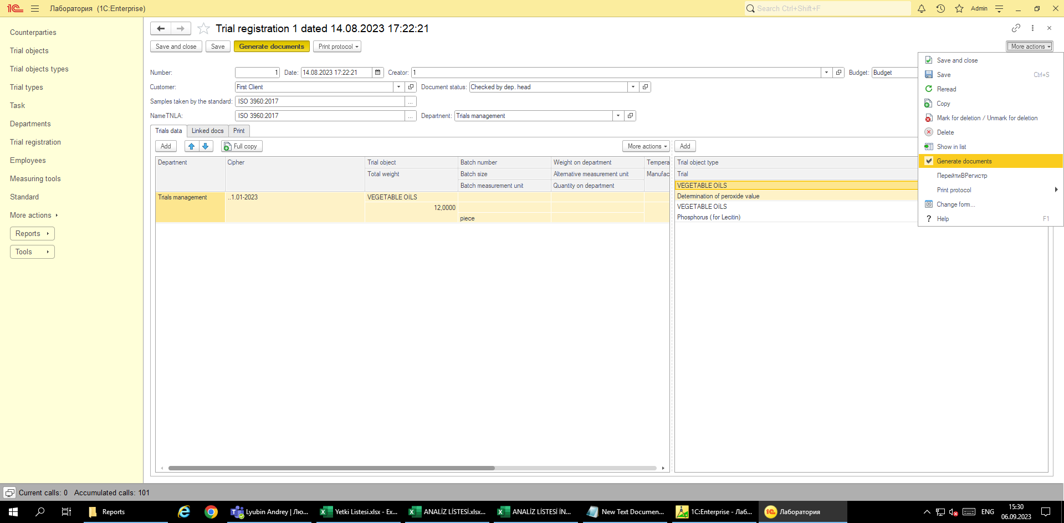

# Entering trial’s results

The command will created or update the **Task** document and add the reference to it to Linked docs tab.

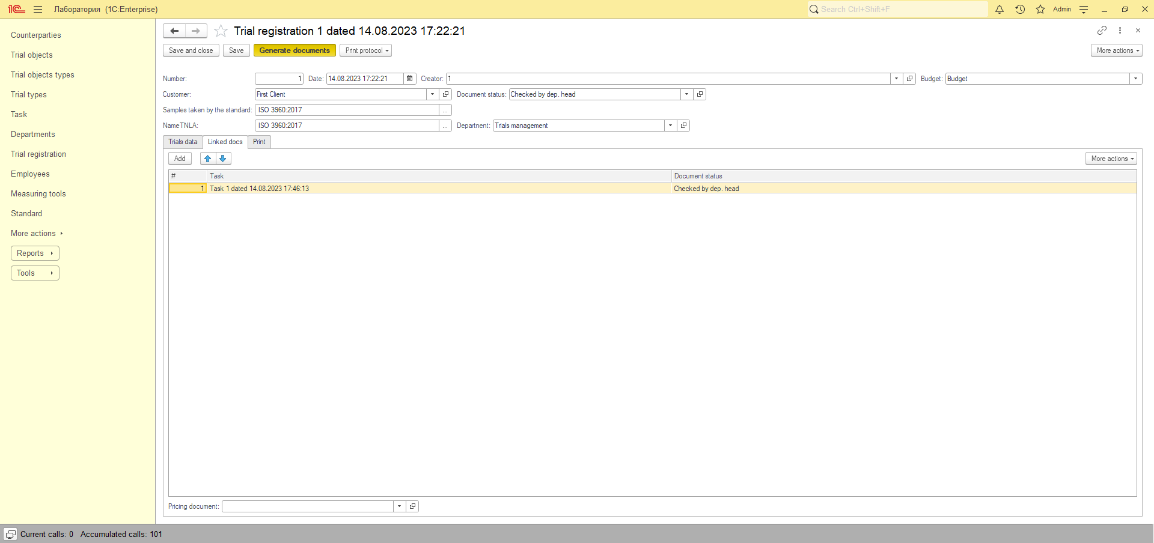

The Task document is designated to keep actual data for trial. In the left table part user can set standards and received value in common. In the right table there detailed information about trial’s results. The field **Corresponds to** serves as the mark whether the received value corresponds to the reference value which is to entered at the steps which are described earlier in this tutorial.

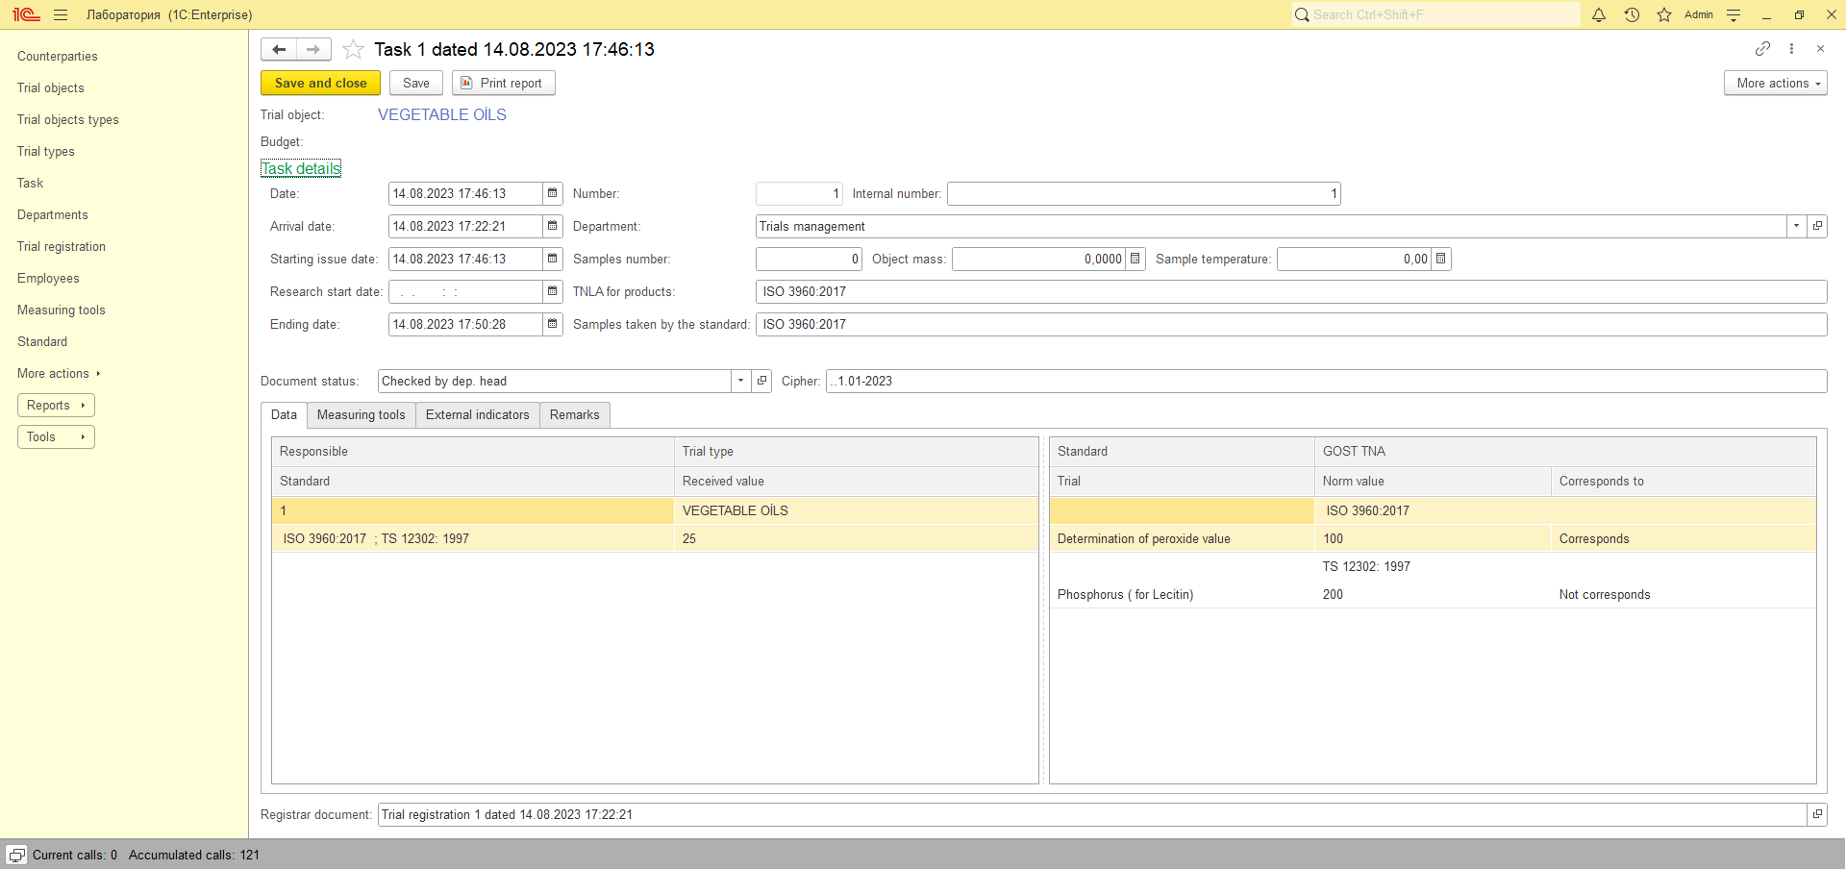

As the result, after entering all required information, the various reports can be printed.

Information about external indicators can be added to the trial’s results too. The available indicators list is show below:

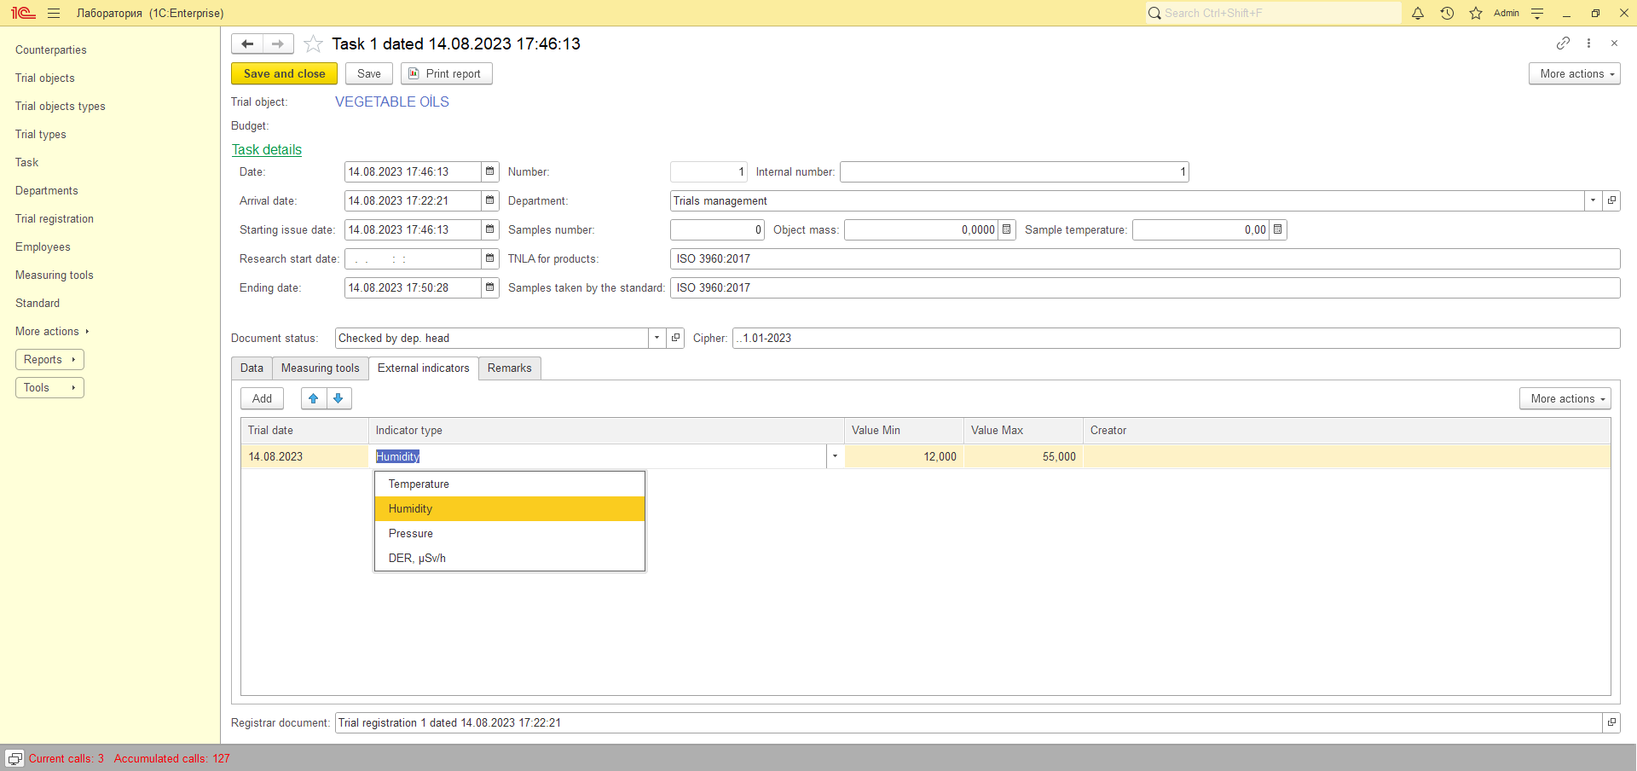

**Tutorial is to change due to updates according required reports.**

## How to activate English interface.

For admins:

*For launch with English interface the following parameters have to be set: /vlen_EN /len*

*Для запуска с английским интерфейсом должен быть указаны следующие параметры: /vlen_EN /len*